Requirements Engineering

- STAKEHOLDER ANALYSIS AND CONFLICT RESOLUTION

1.1 Stakeholders and their interests
- Principal: They are the main sponsor for the system. They want simplicity for non-IT staff and no mark to be seen by students before moderation.
- Lecturers: They set the work, mark and grant extensions if needed. They want the marks to reach the students quickly and for flexible extensions.
- Heads of Department: They moderate and release marks.They want a consistent penalty rule, ability to correct errors and have sight of every mark.
- Students: They submit work and read marks.They want to be able to resubmit, have written feedback, privacy and no rejection of late work.
- Administrator: They manage accounts, courses an enrollments for about 800 students. They want simple screens and a fast set up.
- IT officer: They install, support and backs up the system. They want offline a password protected system they can use offline with speed to accommodate 800 students.

1.2 Conflicts and ambiguities
Conflict: The principal wants no student to see their mark until the HOD checks while the lecturer wants the mark to be visible as soon as they are marked.

Resolution: Two step visibility rule,that is the marked state is visible only to the lecturer and the HOD while the released state is the only one students ever see.

Ambiguty: After resubmitting which version is marked and can a student resubmit after the deadline?
Resolution : The latest version after the deadline is marked and there is no resubmission afetr the deaaline unless it is specified.
Ambiguity: How do penalties and extensions interact?
Resolution: The penalty is measured from the extended deadline.
Ambiguity: Can the HOD change a mark?
Resolution: The HOD may adjust a mark with a mandatory reason
Ambiguity: After 3 days late is the work still accepted and given as feedback?
Resolution: The work is accepted and recorded with a zero mark.
Ambiguity: Does 10% of the available mark mean 10% of the maximum mark or of the earned mark?
Resolution: Treat it as 10% of the maximum mark per late day.

- SOFTWARE REQUIREMENTS SPECIFICATION

Scope: The moderated system manages users, courses, assignments, submissions, marking, moderation, and release marks for students, lecturers, HOD and administrator. It runs offline on a single school computer or a local network.

Out of scope: Online payment, video conferencing,automated grading, plagiarism detection, web or mobile interfaces.

  - Functional Requirements

Must requirement: What the implementation must deliver.
Should requirement: These are built only after the must requirements and their tests are complete.
Could requirement: These are only implemented if time remains.
REQUIREMENT | PRIORITY | VERIFICATION
The system shall allow each user to login with a password and username | Must | Unit and system tests
The system shall enforce role-based access control so that each user performs only what they should do | Must | Unit test per role
The lecture shall mark a submission and give written feedback | Must | System test
The Administrator shall manage departments and courses | Must | Acceptance test
The Administrator shall assign lecturers to courses and enrol students | Must | Acceptance test
The lecturer shall grant an individual extension | Must | Unit test
The student shall resubmit an assignment before the deadline | Must | System test
The student shall resubmit before the deadline and the latest version marked | Must | System test
The HOD shall review and moderate every mark in their department before release | Must | System test
The system shall not show a student any mark for a submission until it is in state Released | Must | System test
The system shall accept late submission and apply a 10% penalty of the maximum mark per day late | Must | Boundary tests
The system shall notify the HOD when a submission is ready for moderation | Should | Unit test
The lecture shall view a dashboard of unmarked submissions | Should | Acceptance test
The HOD shall release approved marks to students | Must | System test
The student shall view enrolled courses and assignments | Must | System test

2.2 Non- functional Requirements

REQUIREMENT | PRIORITY | VERIFICATION
The system shall operate fully offline | Must | Manual test with disabled network
Every release shall be tagged in Git with release notes | Should | Repository inspection
The system shall store at least 800 students, 60 staff accounts and 60000 submission records | Must | Load test with loaded data
Login shall complete within 2 seconds with 800 students stored | Must | Timed system test
The system shall run on a single machine with a 2GB RAM | Must | Install and run on a min-spec machine
Passwords shall be stored as salted hashes | Must | Code review and database inspection
All database access shall use parameterised queries | Must | Code review and static analysis
All marks shall be auditable | Must | Code test
The system shall be buildable from a clean clone using a CMake and C++17 compiler in one command | Must | CI test
- USE CASE MODEL

3.1 Actors
- User: Abstract actor , login is common to all
- Administrator: Manages users, departments, courses, enrolments
- Head of Department: Moderates and releases marks for their department
- Lecturer: Creates assignments, grants extensions and marks submissions
- Student: View courses, submits work and views released marks

3.3 USE CASE DIAGRAM
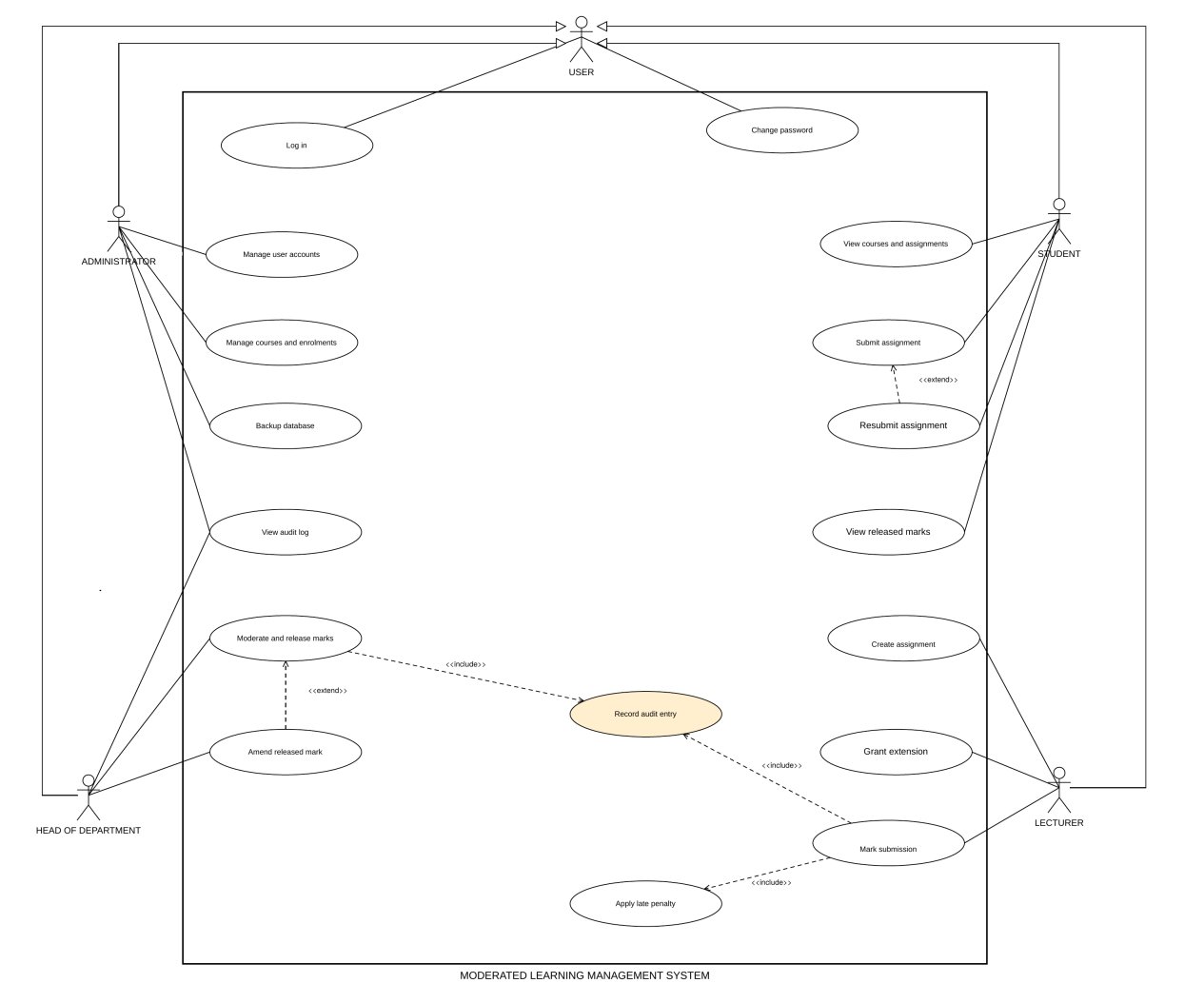

RELATIONSHIPS USED
- Include: “Moderate and release marks” includes “Record audit entry”, “Mark submission” includes “Apply late penalty” and “ Record audit entry”.
- Extend: “Resubmit assigment” extends “Submit assignment” and “Amend released mark” extends “ Moderate released mark”.
- Actor generalisation: ADMINISTRATOR, HOD, LECTURER and STUDENT inherit from USER.

3.4 BUSINESS RULES
- Late penalty: If the days late is zero then there is no penalty , if the days late is one, two or three then the final mark is the raw mark minus (10% of the maximum mark) x days late. If days late is four or more then the final mark is zero.
- Days late: Lateness is the submission time minus the effective deadline. If days late is zero then lateness is zero, otherwise days late is lateness divided by 24 hours, rounded up. Weekends and holidays also count as regular days.
- Effective deadline:This is the later of the assignment and any extension for that student. An extension may be granted , needs a clear reason and must be later that the current effective deadline.
- Resubmission: A student may replace a submission only while it is SubmittedS and the effective deadline has not passed. At most five versions and the latest version is marked.
- Visibility: A lecturer sees marks they entered once. HOD sees marked submissions of their department. A student sees a mark and feedback only when the state is Released.
- Closing: After the lecturer closes an assignment no new submissions or versions are accepted
- Passwords: At least 8 characters and not equal to the username
- Life cycle: Submissions move only through the states Submitted->Marked->Returned->Moderated->Released and Late is a flag.
- Independence: No one is able to moderate or amend submissions for a course they teach.

3.5 USE CASE SPECIFICATION: MARK SUBMISSION

- Primary actor: Lecturer
- Stakeholders and interest: Lecturer wants quick and error-proof marking , Students wants fair mark and written feedback, HOD wants a complete and auditable mark to moderate and the School wants a record of every change
- Trigger: The lecture selects a submission from the list of submissions of on of their assignments.
- Preconditions: Logged in as a lecturer to the course, the submission is Submitted, Marked or Returned
- Relationships: Includes Apply late penalty and Record Audit entry
- Success postcondition: The submission has a raw mark, feedback , penalty and final mark, state Marked, and one new audit entry. It appears in the HOD queue and the student cannot see it
- Failure postcondition: No change and no audit entry

Main success flow

ACTOR | SYSTEM
Chooses a course and assignment | Lists submissions of that course only with student, latest version, time late flag , days late and state
Selects a submission | Shows details, offers to export the file to a folder so it can be read
Chooses “Mark” | Asks for the raw mark
Enters the raw mark | Validates if the raw mark is a number in range with at most one decimal place
Enters written feedback | Validates if it not blank with 1-2000 characters
 | Calculates the penalty and final mark and shows breakdown
Confirms | Saves the mark, feedback, penalty and final mark, sets state to Marked and writes the audit entry all in one go
 | Confirms:”Marked. Students cannot see it until HOD releases it”

Alternative flows
- Revising a mark or remarking a Returned submission: System shows the current mark and feedback. The lecturer enters new values and a reason for change, the audit entry records old value, new value and reason.The state goes back to Marked.
- On time work: The breakdown shows “no penalty”.
- Several versions exist: Only the latest version is offered for marking and earlier versions are listed for information.

Exception flows
- Raw mark is not a number: An error message is issued and actor is re-prompted.
- Feedback empty or longer than 2000 characters: An error message is issued and actor re-prompted.
- The course is not one the lecturer teaches: Access is denied and nothing about submission is shown.
- No reason is given for revision: the actor is re-prompted
- Submission already Moderate or Released: A banner message “ only the HOD can change this mark” appears.

3.6 USE CASE SPECIFICATION: SUBMIT ASSIGMNENT

- Primary actor: Student
- Stakeholders and interests: The student wants proof of submission, a chance to fix mistakes and to be allowed to submit late. The lecturer wants the right file with a trustworthy time. HOD wants for penalties to be applied equally. The principal wants a simple and easy to use system.
- Trigger: The student chooses “Submit assignment” from the student menu
- Preconditions: The student is logged in and enrolled in the course, and the assignment exists and is not closed.
- Relationship: Extended by Resubmit assignment.
- Success postcondition: A new submission version exists in state Submitted with its time, late flag and days late recorded, earlier versions are kept and no mark or feedback is shown.
- Failure postcondition: No submission data changed

Main success flow

ACTOR | SYSTEM
Chooses “Submit assignment” | Lists the student’s assignments with effective deadline and state
Selects the assignment | Checks enrolment and that the assignment is still open
Enters the path of the file | Validates that the file exists, is readable and not empty
 | Reads the system clock and compares it with the effective deadline
Confirms submission | Stores the file as version 1, sets the state to Submitted and records the time and on-time status at the same time
 | Shows a receipt with version, the time and submission number

Alternative flows
- Resubmission : The system states that the new file will replace the current version for marking and that the older versions are kept
- Late submission: The system warns “ This work is (days late) days late and a penalty applies. If the days late is more than 4 “ The mark will be zero” message is issued and the student confirms
- An extension is given: The extended deadline is shown and used

Exception flows
- Assignment is not found or the student is not enrolled in that course: The system refuses the action with no data changes
- Assignment is closed: A message “ Closed for submissions” is issued and the system returns the student back to the list of assignments.
- File missing, unreadable or empty: The reason for error is shown and the student may enter another path or cancel
- Resubmission is not allowed, deadline has passed or 5 versions has been reached : The system rejects the action and the existing version remains unchanged.
- Idle timeout: Session ends and the student is prompted to login again

3.7 USE CASE SPECIFICATION: MODERATE AND RELEASE MARKS

- Primary actor: Head of Department
- Stakeholders and their interest: The HOD wants to see every mark before it is released and wants to be able to fix errors. The principal wants nothing to reach the students unchecked. The lecturer wants the marks to be released promptly. The student wants fair and explained feedback
- Trigger: The HOD opens the moderation queue and chooses an assignment
- Preconditions: Logged in as the HOD , at least one submission is Marked in a course of that department that the user does not teach.
- Relationships: Includes Record audit entry and is extended by Amend released marks
- Success postcondition :Chosen submissions are moderated or Released as decides, adjusted marks have audit entries and released submissions are visible to students with feedback.
- Failure postcondition: Either every selected submission is released or none is
Main success flow
ACTOR | SYSTEM
Opens the moderation queue | Lists assignments of the department with the number of Marked submissions with oldest first
Selects an assignment | Lists its Marked submission with student, lecturer, raw mark, days late, final mark and feedback
Reviews a submission and chooses “ Approve” | Sets the state to Moderated and records the moderator and time
Repeats for other submissions
Chooses “ Release approved marks” | Shows how many Moderated submissions will be released and asks for confirmation
Confirms | Sets all the submissions to Released and records the release time and user
 | Students can now see the raw marks, penalty, final mark and feedback

Alternative flows
- Adjust mark: HOD enters a new mark and a mandatory reason. The system recalculates the penalty using the same rule, shows the breakdown and on confirmation saves it, writes an audit entry and sets state to Moderated.
- Release some and not all the marks: HOD selects the approved submissions to release while the rest stay Moderated.
- HOD leaves without releasing: Moderated submissions stay moderated and invisible to students
- Amend a released mark:HOD selects a Released submission, enters a corrected raw mark and a reason. The state stays Released and an audit entry is written.

Exception flows
- The submission is in another department or in a course the HOD teaches: The action is refused and another Head must moderate it.
- Adjustments without reason or an invalid mark: The action is refused and the Head is reprompted.
- The state changed since the list was loaded: The action is refused for that submission and the list is refreshed.
- Idle timeout: Approvals already confirmed are saved and unreleased ones stay Moderated

REFERENCES

JGraph Ltd. (2026) draw.io (diagrams.net) [Software]. Available at: https://www.diagrams.net/ (Accessed: 11 October 2026). Used to draw the use case diagram in section 3.3.
Anthropic (2026) Claude [Large language model]. Available at: https://claude.ai (Accessed: 11 October 2026). Used to help amend the use case diagram in section 3.3.

